
BasiX 5 FLEX Elite

USER’S MANUAL AND MAINTENANCE GUIDE

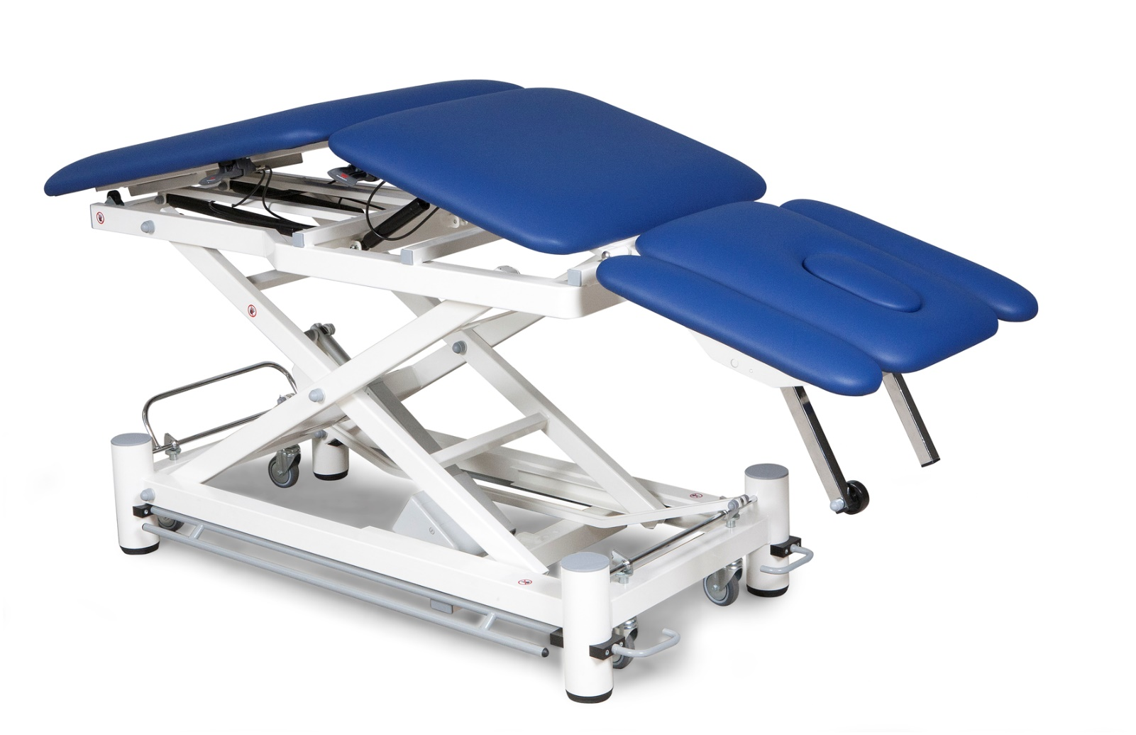

CONTENTS:
1. | General information  - Manufacturer  - Equipment intended use and description  - storage  - Symbols | 2  - 2  - 2  - 2  - 2
2. | Special warnings and use restrictions | 3
3. | Use  - Starting up  - Setting up and adjustments  - Transportation and brakes | 3  - 3  - 3  - 5
4. | Use en setting up accessories | 6
5. | Cleaning and conservation | 9
6. | Maintenance  - Preventive maintenance  - Corrective maintenance  - Spare parts | 10  - 10  - 10  - 10
7. | Troubleshooting | 10
8. | Technical data sheet | 11
9. | Warranty | 12
10. | Service record | 12

1. GENERAL INFORMATION

MANUFACTURER
Wesseling BV, Venenweg 31, 1161 AK Zwanenburg, Netherlands-Tel.+31 204975183-Fax+31 204975909 – website:www.wesseling-bv.com

EQUIPMENT INTENDED USE AND DESCRIPTION
The BasiX tables are intended for examining and treating patients. With the additional options this table can be used for a wide range of treatment and examination. The entire frame is epoxy powder coated and the top is upholstered and covered in fireproof synthetic leather. It’s equipped with a high quality actuator for height adjustment. Head section as well as back section can be inclined with the help of gas springs. The gas springs are all adjusted by handles that are easy to access on the side of the table or on the head section. The brakes and lock are centrally controlled by means of a foot pedal that is easy to activate.

STORAGE
When storing, the following conditions must be met:
1. Relative humidity 10% / 90 % - temperature -10°C / +50°C

SYMBOLS
The various symbols appearing in this manual and on the equipment itself are meant to draw the user's attention on important safety warnings and useful information. Please observe all warning, caution and hazard notices.

 | WARNING  Warning messages are used to advise users/patients about any risk of injury or danger if the specified procedures and conditions are not carefully observed during operation or maintenance activities.
 | ELECTRIC SHOCK HAZARD  This warning symbol identifies operating/maintenance instructions or procedures which, if not observed, could result in a risk of electric shock
 | CAUTION  Caution symbols are used to advise users about an operation or maintenance procedure, best practice or condition that may damage the equipment if not duly complied with.

2. SPECIAL WARNINGS AND USE RESTRICTIONS
Equipment must not be used:
- Without knowing the user’s manual.
- When the safety load exceeds the stated capacity.
- Without the patient being monitored.
- When the patient and/or equipment is not stable enough.
- When table is not on its feet when stopped, during treatment, or when patient is moved to/from other equipment.
- When the original product has been tampered with and/or modified from its original configuration.
- When the controls and/or components are even only partially faulty or defective.
- When incorrectly configured or when you think it may cause damage to a patient or user.
- Do not allow any body parts to enter the areas with moving components and/or controls.
- Do not connect to an electric system that does not comply with the current safety regulations.
- Never spill liquid of any kind on the electric equipment.
- Always unplug the mains power supply before working on any electrical parts or to move the equipment.
- Do not damage the electric cables: avoid crushing; do not pull out the cable to disconnect, etc.
- Electric cables should be checked regularly to see if they are damaged. In case of doubt, have them replaced.
- Foam rubber and plastic components may burn if they come in contact with naked flames.
- Corrosive and/or abrasive detergents may damage the covers and paintwork.
- The equipment is not suitable for use outdoors and/or in surfaces that are not smooth enough.
- UV and heat therapy lamps may damage the upholstery covering.
!!!!!!!!!! NEVER LEAVE THE TABLE UNATTENDED WHEN THERE IS A PATIENT ON IT !!!!!!!!!!!

3. USE
STARTING UP
For packaging reasons the couch is supplied covered by protective means that are to be removed, avoiding direct contact with cutters that could damage it. Any damage in transit must be reported to the transporter and seller immediately, without using the equipment for safety reasons.
SETTING UP AND ADJUSTMENTS
The table has an electric actuators for the height adjustment. The head section and the back section are both fitted with gas springs.
ADJUSTMENT/FUNCTION | CONTROL | PROCEDURE
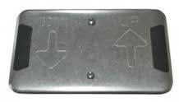 | 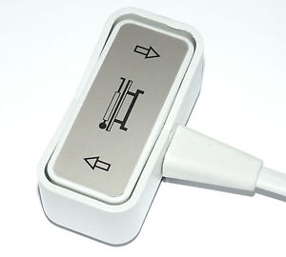 | Table is standard equipped with a 24v foot switch or hand switch.
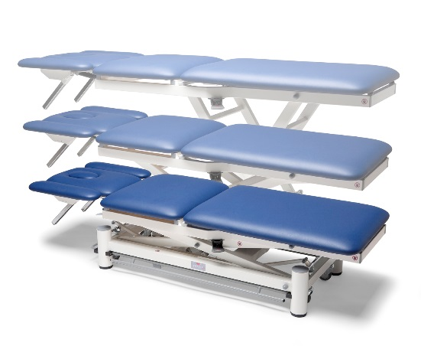 |  | Push the relevant symbol to adjust the height of the entire table.
 | 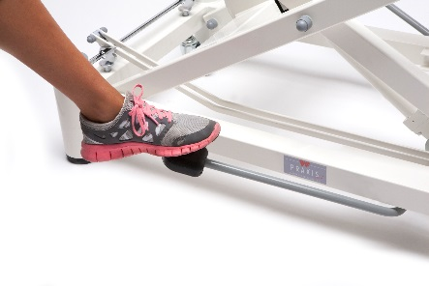 | A hydraulic table is equipped with a hydraulic pump with foot pedals on both sides of the table.  The height adjustment by means of the pappels:  Up:  - Push down the pedals with your foot by pressing the designated footpath. Repeat until the desired height is reached.  Down:  - Push up the pedals with your foot by pushing the designated footpath. Keep pushing until the desired height is reached.
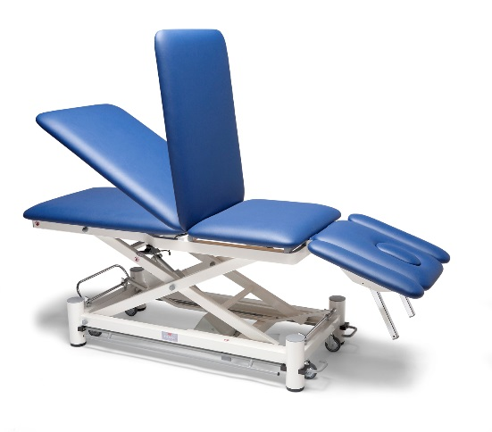 | 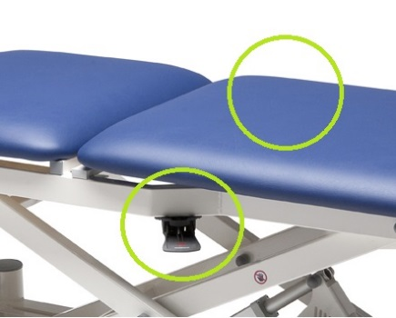  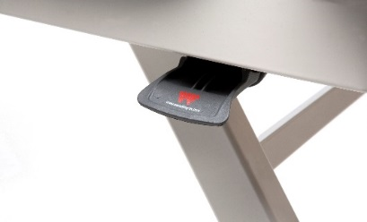 | To adjust the back section pull the control handle, and support the section as it moves. Release the handle to secure the position. The control handles are on both sides of the table.    - With the patient’s weight on the section, activate the control handle only when you are sure that the entire load is supported.  - Movement of the adjustable sections may cause pinching in the vicinity of the hinges.  - Only sit on the back-section when it is supported by the frame. Do not sit on this section when it is in an angle.
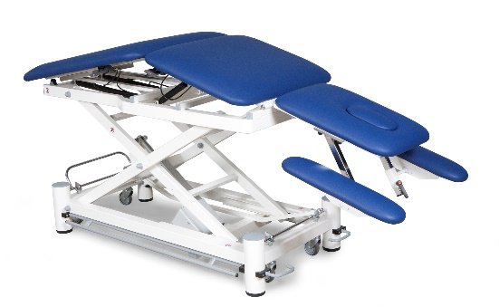 | 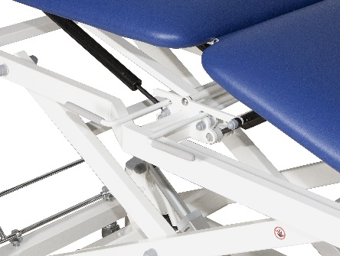 | To adjust the middle section pull the control handle, and support the section as it moves. Release the handle to secure the position. The control handles are on both sides of the table.  - With the patient’s weight on the section, activate the control handle only when you are sure that the entire load is supported.  - Movement of the adjustable sections may cause pinching in the vicinity of the hinges.  - Only sit on the middle-section when it is supported by the frame. Do not sit on this section when it is in an angle.
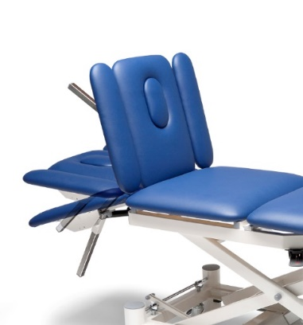 | 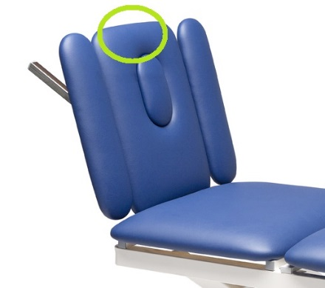 | To adjust the head section pull the control handle, and support the section as it moves. Release the handle to secure the position. The control handle is under the head section  - With the patient’s weight on the section, activate the control handle only when you are sure that the entire load is supported.  - Movement of the adjustable sections may cause pinching in the vicinity of the hinges.  - Do not sit on the head section
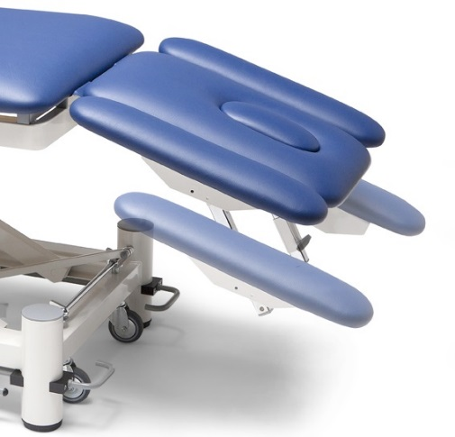 | 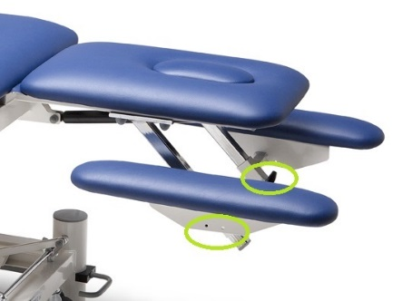 | To adjust the armrests loosen the lever of the armrest you want to adjust. Move the armrest in the desired direction and fasten the lever to keep it in place.  - With the patient’s weight on the section, loosen the lever only when you are sure that the entire load is supported.  - Movement of the adjustable sections may cause pinching in the vicinity of the hinges.  - Do not sit on the armrests.

TRANSPORTATION AND BRAKES
The table has four swivel wheels to allow movements in tight spaces. At the back-side of the table is the stirrup bar of the wheel-lift system. By pushing this stirrup bar downwards the table becomes mobile. Lift the stirrup bar upwards again after reaching the required position so the castors will be retracted. Never use the table if the castors are not fully retracted! The 4 feet can be adjusted individually when the floor is not even.
MOVING THE TABLE | PUT THE TABLE ON ITS FEET | PROCEDURE
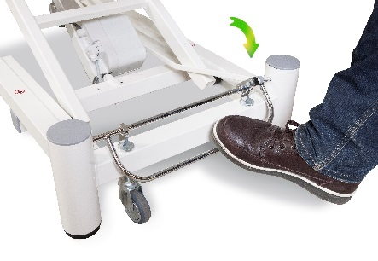 | 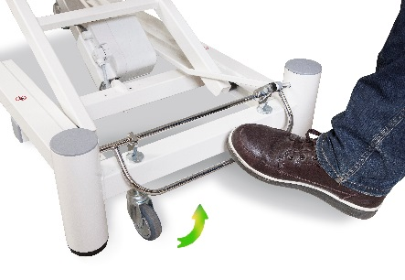 | - To move the table use the foot to push down the bar till it stops.  - To put the table on its feet use the foot to push up the bar until all the feet are on the floor.


- Putting the table on its feet is essential when transferring and treating the patient.

4. USE AND SETTING UP OPTIONS

With the use of the optional accessories this table can be used for multiple treatments.

PAPRAX: Paper roll holder Praxis  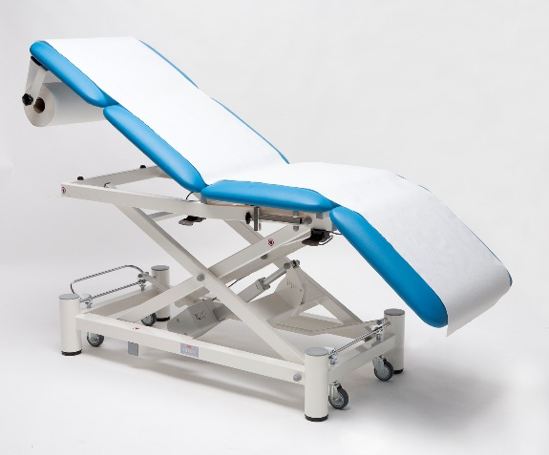 | 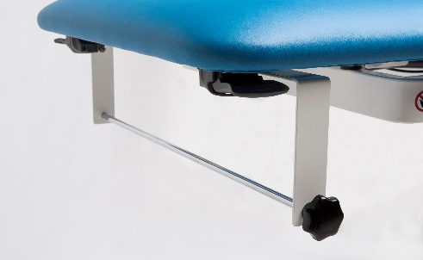 | The paper holder is always mounted on the head-section of the Praxis. The maximum roll width that fits into holder 60cm.  Placing a roll of paper:  - Turn the knob and pull the rod out of the holder.  - Place the paper roll in the holder and push through the rod.  - Tighten the knob to hold the rod in place.
RONDOM7: Barswitch-system Praxis  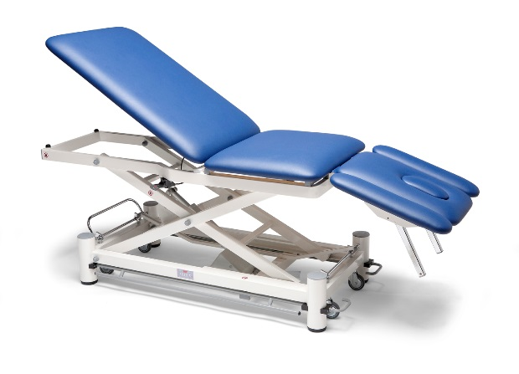 | 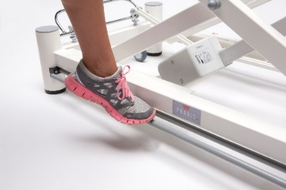  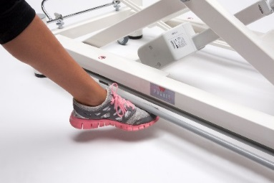 | By choosing to barswitch-system the standard switch will not be on the table. By pushing the bars which are located on both sides of the table, you can adjust the height of the table.  Adjusting the height from the side:  - Push down one of the bars to let the table go down. Stop pushing when you have reached the desired height.  - Push up one of the bars to let the table go up. Stop pushing when you have reached the desired height.  - The barswitch-system can also be activated when sitting at the head-section. The two special made bars s work in opposite direction that the bars on the side.
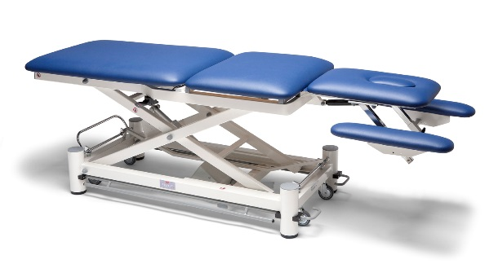 | 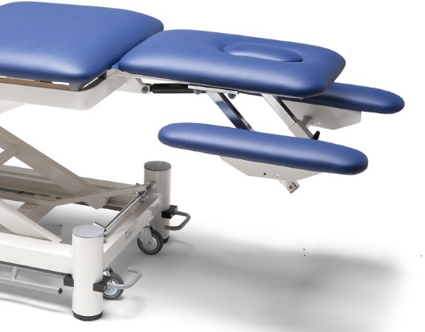  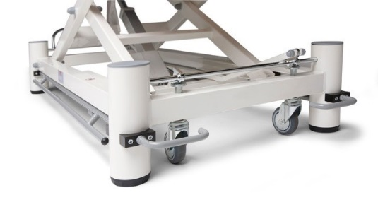 | This new barswitch-system can also be activated when sitting at the head-section. The two special made bars s work in opposite direction that the bars on the side.  Adjusting the height from the head-section:  - Push up one of the bars to let the table go down. Stop pushing when you have reached the desired height.  - Push down one of the bars to let the table go up. Stop pushing when you have reached the desired height.
HSCH006+TSTUK00:  Extra handswitch | 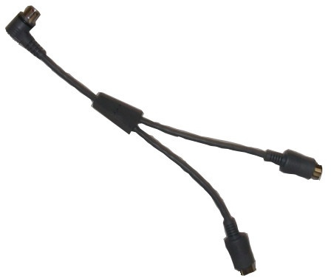 | Standard the table is mounted with one switch of choice. We can equip the table with multiple switches. If you choose for an extra hand switch, you also need a link to connect two switches on the motor. If this option is chosen, the link (Y-cable) and the extra switch will assembled on the table before delivery.
VSCH005+TSTUK00:  Extra footswitch  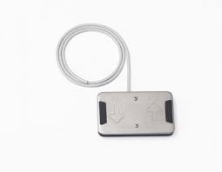 |  | Standard the table is mounted with one switch of choice. We can equip the table with multiple switches. If you choose for an extra foot switch, you also need a link to connect two switches on the motor. If this option is chosen, the link (Y-cable) and the extra switch will assembled on the table before delivery.
NEUS002: Breathing-hole in head-section  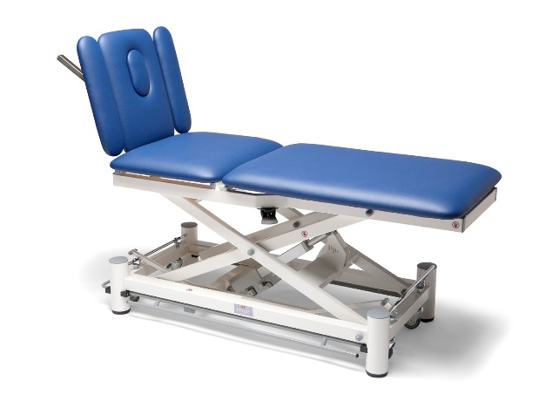 | 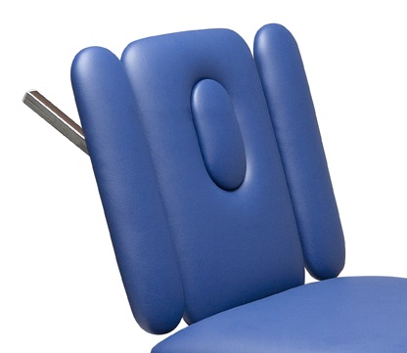 | Each Praxis can be mounted with a head-section with cut-out. When choosing this option there will be a plug in the color of the table to fill the cut-out.
LAZYFOAM: memory foam  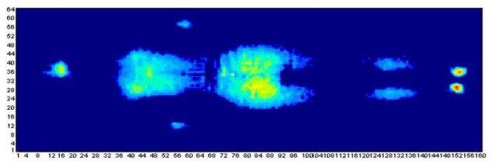 | 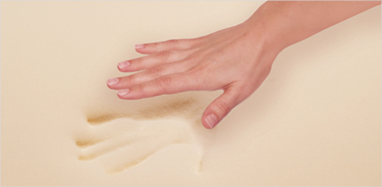 | The standard parts are filled with polyether and are about 55mm thick. When the optional Lazy Foam is chosen the total thickness is 70mm. The upholstered sections will not only be thicker but also softer and therefore more comfortable for patients who need to be longer on the table.
MASK003: Neckcushion with velcro strap  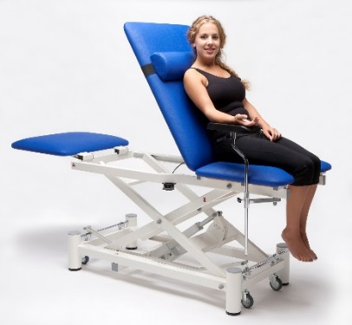 | 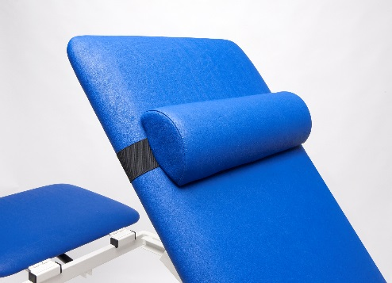 |  | This neck pillow ensures that the patient can sit/lie comfortably. The cushion has an elastic strap on the rear with Velcro closure. This is to position the cushion at almost every place. The cushion has a size of 58x18x9cm. The cover on the back is also equipped with a zipper and thus removable.
BREEDTE00: Different width 70cm  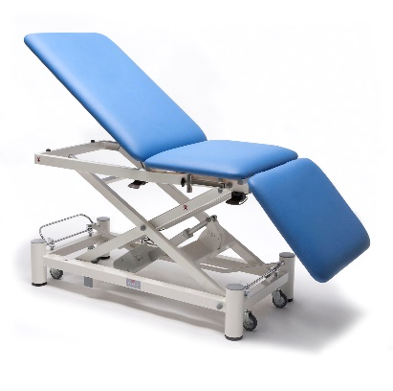 | 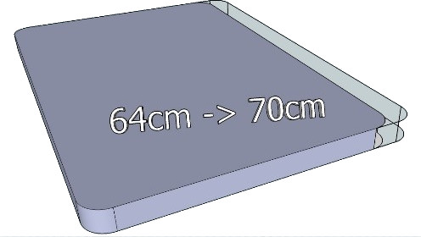 |  | The standard width of a Praxis Elite is 64cm. If this is not wide enough, the table can be optionally expands to 70cm. The length of the table will therefore not change.
MOTSL95: Extra strong actuator with max. 12.000N  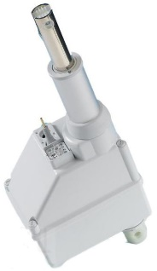 | MOTSL95: Extra fast actuator max. 14 mm/s |  | The table is standard equipped with an actuator with a force of 8.000N at a rate of 7.5 mm / s. We can adjust, by means of the placement of a different actuator, the speed and / or the force. The choices are as followed  8.000N = 14 mm/s  10.000N = 10 mm/s  12.000N = 8 mm/s

5. CLEANING and CONSERVATION
For durable joy with the leather material, please clean regularly. For cleaning use a cloth or soft brush dampened using water and a neutral detergent. Any stains on the upholstery should be promptly removed with colourless ethyl alcohol diluted in 20% water. Rinse well.
- ENSURE THE COUCH IS PERFECTLY CLEAN BY DISINFECTING THE SYNTHETIC LEATHER AND APPLYING A SINGLE-USE PAPER SHEET AT EVERY USE.
- HARSH DETERGENT PRODUCTS MAY DAMAGE THE SURFACES.
- DO NOT USE STEAM JETS, WASHING TUNNELS, WATER JET CLEANERS OR HIGH PRESSURE WASHERS
6. MAINTENANCE

Maintenance operations must be carried out by technicians who are familiar with the contents of this instruction booklet.
Check the equipment is safe after any instances of "rough handling" (e.g. fall, bumps, etc.) and any time you are in doubt about safety.
ROUTINE MAINTENANCE
Routine maintenance operations must be carried out with the frequency indicated in the table.
FREQUENCY | ACTIVITY
Every 6 months or at least once a year | General equipment cleaning.
Every 6 months or at least once a year | Visual and functional inspection of the equipment and related hydraulic and manual controls.
Every 6 months or at least once a year | Frame and mechanical parts: Check screws and bolts are tight; state of wear of bushings and pins, presence of tears and deformations or damages.
Every 6 months or at least once a year | Oil leaks from the piston and/or gas springs must only be in the form of minor lubrication residue.
Every 6 months or at least once a year | Check that the adjustable sections are stable and do not give way when the control lever is released.
Every 6 months or at least once a year | Brake control: check regular functioning of the activating device and the efficiency of the brakes.
Every 6 months or at least once a year | Wheels: these must be securely fixed and in good condition, rolling smoothly and with their treads free of impediments.
Every 6 months or at least once a year | During use and operation, make sure there are no unusual sounds, vibrations or oscillations that may indicate actuator and/or mechanism malfunctions.
At the end of the activities above, complete the inspection performing a lift cycle with the stated maximum safe load.
NON-ROUTINE MAINTENANCE
For safety reasons and to avoid invalidating the guarantee, no component may be opened or handled for repair. Any faults on the hydraulic piston, the gas springs and the wheel system must be diagnosed by Wesseling BV, who will organize the most suitable action.
- IF SAFETY SEEMS TO BE AT RISK, DISABLE THE EQUIPMENT IMMEDIATELY PREVENTING ANY POSSIBILITY OF USE UNTIL SUCH RISK HAS BEEN REMOVED.
- PLEASE RECORD ANY DEFECTS/DAMAGES/SERVICES THAT ARE IMPORTANT FOR THE SAFETY OF THE EQUIPMENT IN THE APPROPRIATE FORM HEREWITH ENCLOSED.

SPARE PARTS
Only use original spare parts from Wesseling. Please contact Wesseling BV for the parts you might need.

7. TROUBLESHOOTING
DIRECT E-MAIL FOR TECHNICAL OR USERS ASSISTANCE:  info@wesseling-bv.com  If you rather want to speak to one of us on the phone you can call: +31-20 497 5183 | 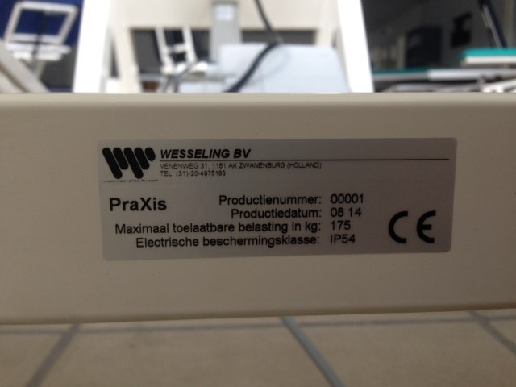
Please note:
- Before contacting for service or help, please identify the "SERIAL NUMBER" in the product label attached to the equipment (see example above), or the transport document/invoice number. This will speed things up and improve service quality.

The equipment was tested in very stringent conditions. During testing no specific breakages or faults occurred.
If the equipment fails to operate, please follow the troubleshooting process below.
Issue | Cause | Solution
Adjustment of the head-/back section  doesn’t work or the position is not maintained | Gas spring faulty or incorrectly set | Contact Wesseling BV
 | Transmission cable damaged or broken | Contact Wesseling BV
One of the actuators does not work | The attached switch is broken or not connected properly | Contact Wesseling BV
One of the actuators does not work | Power cable is damaged or not connected properly | Contact Wesseling BV
One of the actuators does not work | Actuator is damaged or not connected properly | Contact Wesseling BV

8. TECHNICAL DATA SHEET
Product Name | BasiX 5 FLEX Elite Electric, with or without wheels | BasiX 5 FLEX Elite hydraulic, with or without wheels
Product Code | BAS5FEMWE /BAS5FEZWE | BAS5FEMWH / BASF5EZWH
Safe working load | 250kg | 250kg
Max patient weight | 225kg | 225kg
Height adjustment | 45cm to 115cm with a speed of 7,5mm/s - 8.000N, 470W, 2.0Ah, stroke 300mm | 50cm to 100cm, , hydraulic pump, 10.000N, stroke 200mm
Adjustment system | German electric actuators | Dutch hydraulic pump
Adjusting electrics | 24v foot- or hand switch | Pedals on both sides of the table
Sections adjusted by gas spring | 3 | 3
Head section | -55° to +85° | -15° to +85°
Middle section | 0 to -25° | 0 to -25°
Back section | 0° to 85° | 0° to 85°
Arm rests | Height adjustable, 0-17cm | Height adjustable, 0-17cm
Adjusting gas spring head section | By lever that is under the head section | By lever that is under the head section
Adjusting gas spring back section | By levers that are on both sides of the table | By levers that are on both sides of the table
Wheels | Ø75mm | Ø75mm
Braking system | Centralized control on the back of the table | Centralized control on the back of the table
Equipment weight | ± 85kg | ± 85kg
Length | 200cm | 200cm
Width | 64cm or 70cm (optional) | 64cm or 70cm (optional)
Upholstery thickness | ± 55mm | ± 55mm
Filling | Polyether SG 90/30 | Polyether SG 90/30
Semi Leather | Standard artificial leather, Original SKAI® or STAMSKIN | Standard artificial leather, Original SKAI® or STAMSKIN

9. WARRANT

GENERAL AFTER-SALES SERVICE CONDITIONS FOR WESSELING ITEMS
The warranty has a 24-month validity from the date of delivery.
The warranty does not cover consumable items, rechargeable batteries, and generally all the material subject to wear, breakdowns caused by knocks, falls, misuse or improper use, accidental events and transport damage. This warranty shall be automatically invalidated if the equipment is tampered with.
Repair of the equipment will be carried out in relation to the breakdown stated.
An estimate must be specifically requested.
Payment is cash on delivery, unless other agreements are made.
For any dispute, the sole competent court shall be the court of Amsterdam
WARRANTY REPAIRS
Warranty repairs must be expressly requested.
Repairs under warranty shall be carried out at our workshop and upon authorization
The return shipment for products sent in their original package will be made free of carriage charges.
A fiscal document (bill of sale, purchase invoice or cash receipt) is required to make a warranty claim; the purchase date indicated must fall within the warranty time period.
If, upon inspection, the product appears to be fully functioning, troubleshooting expenses shall still be charged to the client.
OUT OF WARRANTY REPAIRS
For out-of-warranty repairs carried out at our workshops upon authorization, transportation charges shall be paid by the customer.
The warranty of the parts replaced during the repair operations is 12 months from the moment the equipment is collected.
If, upon inspection, the product appears to be fully functioning, troubleshooting expenses shall still be charged to the client.
REPAIRS MADE AT HOME
In the event repairs are made at the customer’s home, a written request is required indicating the complete details of the person making the request, the type of machine and the breakdown.
The cost per kilometer for on-site technician visits will be agreed upon in relation to the urgency of the customer.
In the event the machine is under warranty, the customer will have to pay only the expenses incurred for the technician to reach the customer’s house.
Time is calculated from the moment the technician leaves our workshop until he/she returns. The time of his/her return will be estimated based on the time required to get there.
SALE OF SPARE PARTS AND CONSUMABLE ITEMS
The orders must be in writing and specify the customer, the item and the shipping method as well as the precise fiscal data of the customer.
The order processing time can vary depending on the availability of the material.
Returned spare parts will not be accepted.
Payment will be cash on delivery, unless other agreements are made.

10. SERVICE RECORD

EQUIPMENT: |  | DATE OF FIRST INSTALLATION: |  | SERIAL NUMBER:
DATE OF SERVICE | OPERATIONS CARRIED OUT |  | TECHNICIAN |  | SIGNATURE | NEXT DUE DATE

